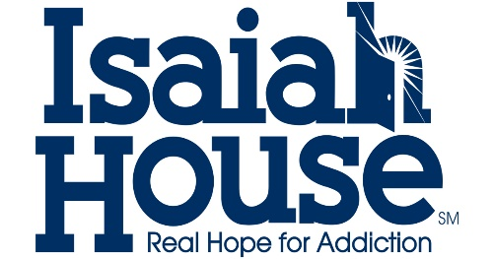

KENTUCKY ADULT PEER SUPPORT SPECIALIST TRAINING APPLICATION

Isaiah House Recovery Center, Inc. is an approved APSS Certification Training provider approved by the Kentucky Department of Behavioral Health. This is a 30-hour virtual training program, and the cost for the registration, materials and training is $350. Training dates will be set by the facilitator once a class roster has been filled. This application consists of your personal information, 3 short essay questions, reference letter from someone attesting to your recovery and a checklist of your qualifications.

This application can be returned to Nick Rhodus by mail: at PO Box 188 Willisburg, KY 40078 or email at nick.rhodus@isaiah-house.org
If you have any questions concerning the training or the application process, please feel free to contact me at (859) 691 0591.

Essay Questions

What does recovery mean to you?

Why do you think peer support specialists are important in the recovery field?

Why do you want to be a peer support specialist?

Reference Letter

Please submit a reference letter from someone who can answer the following question:

How does the applicant demonstrate a pattern of recovery from their substance abuse or mental health disorder?

Reference Information

Name:

Relationship to applicant:

Mailing Address:

Email address:

Checklist
I am over 18 years of age. _____

I have a high school diploma. _____

I can supply documentation of a high school diploma or GED. _____

I have a primary diagnosis of a substance abuse/mental health disorder. _____

I have received treatment for my substance abuse/mental health disorder. _____

I can demonstrate recovery from my disorder. _____

____________________________________________
Signature Date

___________________________________________________
Print Name Phone Number Email

